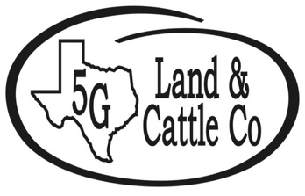
Comanche Chamber of Commerce &
5G Land and Cattle Co.

82nd Annual Open Rodeo
Parade Entry
Saturday, June 17th, 2023 at 5:00 PM

Rules and Regulations:
- Lineup will be no later than 4:00 pm on West Grand Avenue in front of the Comanche Funeral Home.
- Candy may be thrown but it must be thrown clear of the float.
- All horses MUST have proof of current Coggins test, and all dogs must have current pet tags, proof of vaccinations, and be on a leash.
- Participants will be judged before the start of the parade and winners will be announced at the Comanche Open Rodeo Saturday, June 17th at 7 p.m.
- There is no specified theme this year.
- Entry form must be turned in on or before June 14th @ 5:00 pm to be signed up for judging. Entry Forms may be emailed to comanchechamberinfo@gmail.com
- Riding Clubs please plan on staying to ride in the rodeo grand entry.
Business/Organization Name: ____________________________________________________
Contact Name: ________________________________ Phone: __________________________
Address: ________________________________City, State, Zip Code: ___________________
Email: ______________________________________________________________________
Entry Description (car, float, horse, etc.): _____________________________________________________________________________
_____________________________________________________________________________
Number of Participants: _________________________________________________________
First Place | Second Place | Third Place | Largest Horse Group
$750.00 | $500.00 | $250.00 | $500.00
For more information, call the Comanche Chamber of Commerce & Ag.
at 325-356-3233

