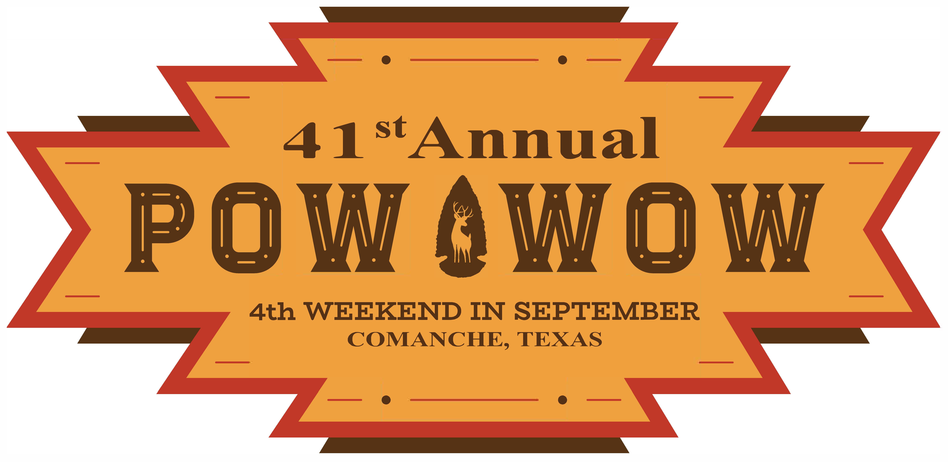

YOU ARE CORDIALLY INVITED TO SHOW AND PARTICIPATE IN

The 41st Annual Comanche County Pow-Wow
ART EXHIBIT & SALE
PRODUCED BY THE COMANCHE COUNTY ART ASSOCIATION

September 24 & 25, 2022

SPONSORED BY: FOR INFORMATION CALL:

Comanche Chamber of Commerce Paula Vaughn Ph: 325-356-5324
Comanche County Pow-Wow Susan Stepp Ph: 325-356-3414
Comanche County Art Association

REGISTRATION:

Comanche Community Center, 100 Indian Creek Dr, on Brownwood Hwy. in Comanche
Date/Time: Thursday, Sept. 22nd from 12:00 noon to 6:00 p.m.
Fees: Adults: $10.00 per entry
Children: $3.00 (grades 12 & under) per entry
Display only: NO FEE

Limit 5 entries per exhibitor
All entries must be dry and ready to hang. Wire only. NO SAW-TOOTH HANGERS
No larger than 30 X 40 or 140 linear inches.

SHOW OPENS: Saturday 10:00 a.m. to 4:00 p.m. Sunday 10:00 a.m. to 4 p.m.

CHECK-OUT TIME: Sunday, September 25, 2022 10:00 a.m. to 4:00 p.m.

RULES & REGULATIONS:

NO EARLY CHECK OUTS
All work must have been done within the last two years and not previously exhibited at the Comanche Art Show.
10% Commission will be charged on all sales.
Each artist will be responsible for collecting sales tax.
Paintings not in good taste will be rejected.
Copy work and/or workshop paintings will be displayed in a separate category.
No computerized drawings.

DIVISIONS & CLASSIFICATIONS:

I. Children Grades 12 and under
A. Work will be classified by grade groupings depending on number of entries.
B. Students wishing to display only--- NO ENTRY FEE

II. Adult
A. Novice - one who has painted for three years or less.
B. Advanced - one who has painted for more than three years.
C. Professional - one who teaches, holds workshops, demonstrates or sells paintings
on a semi-regular basis.

CASH AWARDS: ADULT
Best of Show $300
Best of Professional $100
Best of Advanced $100
Best of Novice $100
CHILDREN
Best of Show $50

PEOPLES CHOICE AWARDS: Awarded in both ADULT and CHILDREN’S divisions

(AWARDS in all categories according to judge's discretion.)

NOTICE: Every reasonable precaution will be taken to protect the entries; however, no responsibility is
assumed by the Comanche Art Association, Comanche Chamber of Commerce, City of Comanche, or Comanche POW-WOW Council for the loss or damage from any cause. All entrants will automatically agree to this clause with entry.

We look forward to seeing you on THE 4TH WEEKEND IN SEPTEMBER!
If you have any questions, please feel free to contact the
Comanche Chamber of Commerce at 325-356-3233 or comancheevents@gmail.com
**Don’t forget to LIKE us on Facebook for POW-WOW updates at www.facebook.com/TheComancheCountyPowWow
And use our personal hashtag on your social media platforms when posting about the event:

#41stAnnualPowWow

The Pow-Wow is a Native American themed event only.
This is not a traditional Native American Pow-Wow

Pow-Wow Committee
P O Box 65
Comanche, Texas 76442

ExploreComancheTexas.com

Phone: 325-356-3233 Email: comancheevents@gmail.com

